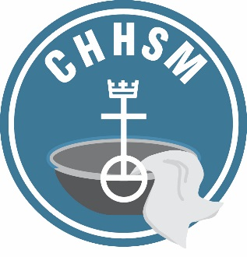
Council for Health and Human Service Ministries
United Church of Christ

November 30, 2017

Dear CHHSM Member,

At General Synod this past year, the National Setting of the United Church of Christ unveiled their new initiative, “3 Great Loves.”

“…and the greatest of these is love.” 1 Corinthians 13:13

CHHSM ministries well know that there is no greater need today than the need to love.

All CHHSM members are being asked to be a partner in the UCC’s 3 Great Loves initiative – an initiative that focuses on Love of Neighbor, Love of Children, and Love of Creation. 3 Great Loves is part of a denomination-wide effort that is about engaging the UCC to take action and to show the impact of your ministry, and the UCC, working together as one church, with one voice and one vision – a vision of A Just World for All. 3 Great Loves begins with the Love of Neighbor effort.

Love of Neighbor can be expressed in many ways. Please visit the 3 Great Loves UCC web site, www.3greatloves.org, to see the many easy and important ways to show Love of Neighbor. CHHSM ministries are the hands and feet of the Church. Let’s spread the news of how we are models in the UCC, and in our communities, to live out the purpose of the UCC: to love God with all our heart, mind, soul, and strength and our neighbor as ourselves. (Mt. 22)

Feel free to display this poster and encourage your staff, clients and residents to participate in the 3 Great Loves initiative. Here are some ideas: take a collection focusing on one of the 3 Great Loves, lead a discussion session on a related issue, or offer an opportunity to do volunteer work in your community. Be creative and have fun with it! We would love to hear back from you about the ways in which you engage with the 3 Great Loves and encourage you to post about it on Facebook and through other forms of social media. See the attached document for instructions about sharing your participation on the Three Great Loves website.

